**Time Spent on Social Media Analysis**

* General Descriptive Analysis (GDA) :

1. Count The total Data Is Available for Analysis in Dataset.

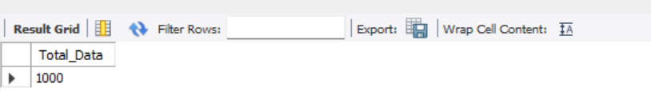

1. Count The total Different Platform Available In Dataset.

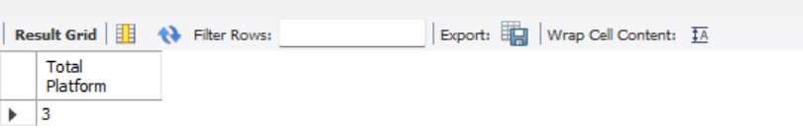

1. Count The total Different Genders Available In Dataset.

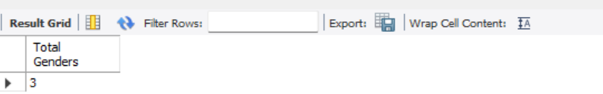

1. Count Average User Age in Dataset.

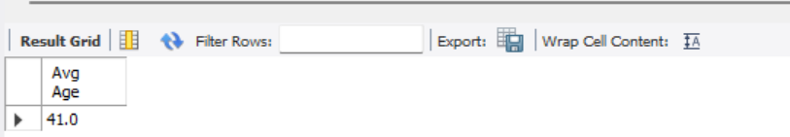

1. Count Average Time Spent on Social Media.

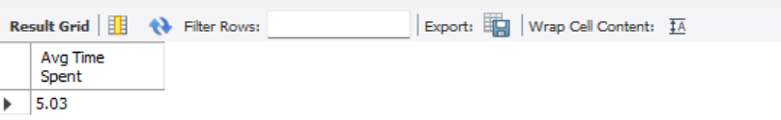

1. Count The Number of Profession Available in Dataset.

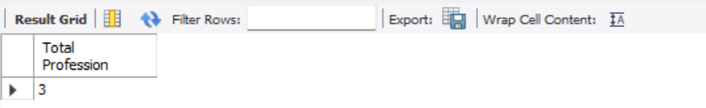

* Exploratory Data Analysis Questions (EDA):

1. Find The Total Count for Each Gender.

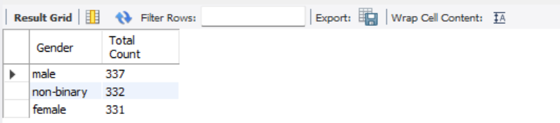

1. Show The Time Spent in Hours on Platform by Gender.

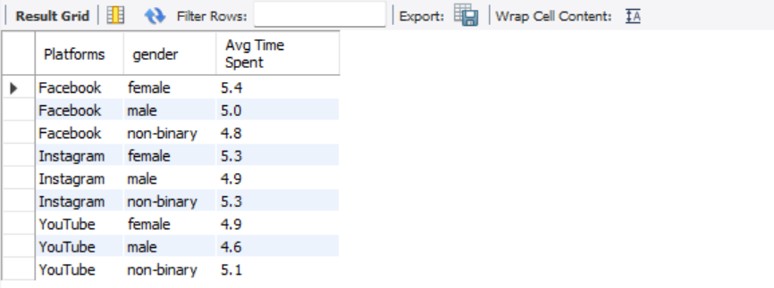

1. Average Time Spent on Platform Available in Dataset.

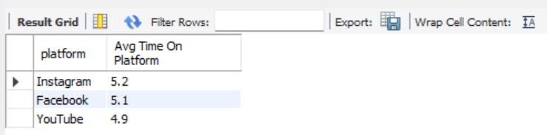

1. Find Total Average Hours’ Time Spent on Platform by Profession.

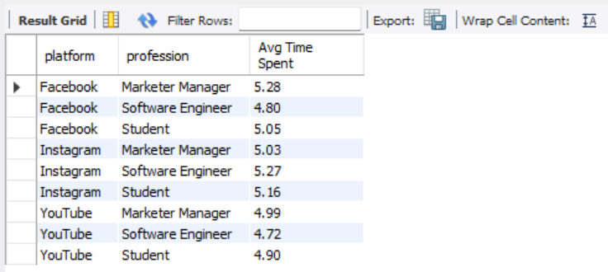

1. Find Total Average Time Spent on Platform by Interests.

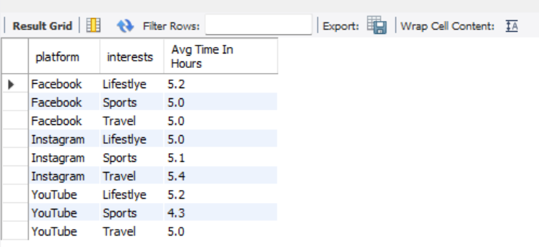

1. Find Total Average Time Spent on Platform by Car Ownership.

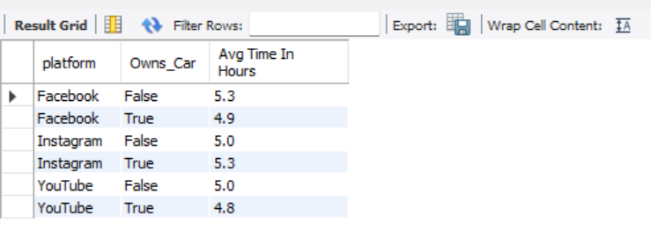

1. Find Total Average Time Spent on Platform by Home ownership.

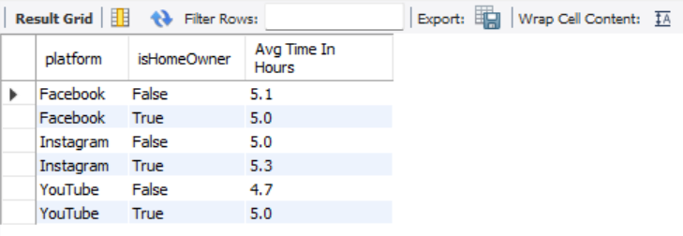

1. Find Total Average Time Spent on Platform by Location.

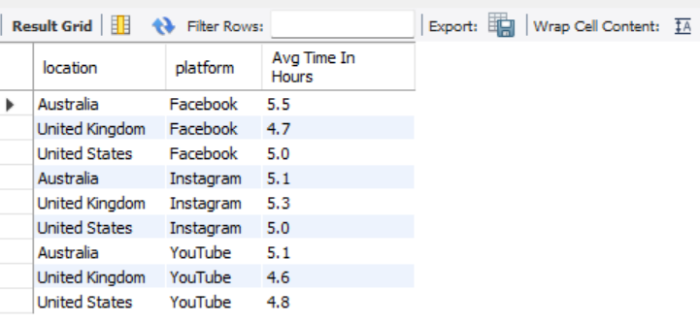

1. Find Total Average Time Spent on Platform by Demographics.

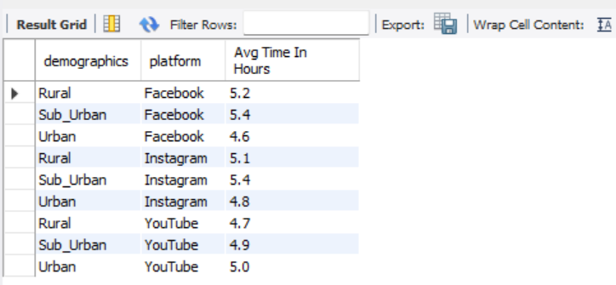

10) Find total Average Time Spent on Platform by Indebt.

